1. INTRODUCTION
In modern computer networking and cybersecurity, understanding how data travels across a medium is fundamental to both maintaining network health and detecting malicious activity. A Network Sniffer (also known as a packet analyzer) is a tool designed to intercept, capture, and log data packets as they stream across a network interface.
By capturing raw network traffic, this project delves beneath high-level user interfaces to analyze data at the protocol level. Developing a custom network sniffer provides a practical baseline for understanding how data encapsulation works, how network protocols interact, and how security analysts expose vulnerabilities, clear bottlenecks, or identify unauthorized data transmissions within a network infrastructure.

2. PROJECT OBJECTIVES
The primary goals of developing this network sniffing application include:
- Real-Time Packet Interception: Build a functional Python script utilizing low-level libraries (socket or scapy) capable of binding to a network interface card (NIC) and capturing live, incoming and outgoing IP packets.

- Protocol Analysis & Decoding: Implement parsing logic to systematically strip down network headers, allowing the application to identify and distinguish between different network and transport layer protocols such as TCP, UDP, and ICMP.

- Metadata Extraction: Successfully extract and display crucial network metrics from each packet payload, specifically tracking the Source IP address, Destination IP address, and Port numbers to chart the flow of communication.

- Security & Inspection Awareness: Evaluate the structural contents of unencrypted payloads to demonstrate the inherent security risks of cleartext protocols (like HTTP, FTP, or DNS), highlighting the critical industry need for robust encryption methods (like HTTPS or TLS).

3. INSTALLATION OF THE SCAPY
I already successfully installed the python of version 3.14.5.Then I successfully installed the scapy library on my system using the ‘pip install scapy’ command. Scapy is a powerful python library used for packet capturing and network analysis in cyber security projects.
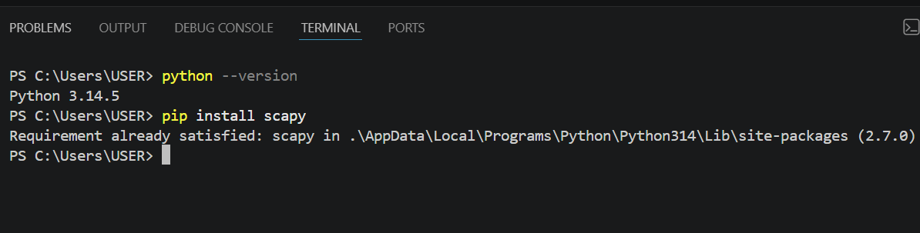

4. CREATING THE PROJECT FOLDER
I successfully created a project folder and a python file named ‘sniffer.py’ inside the visual studio code. In the code screenshot I imported the function from the scapy library and created a call back function called ‘packet callback’. This function prints the summary of each captured network packet. The program starts packet capturing using the sniff function it captured 20 packets from the network library.
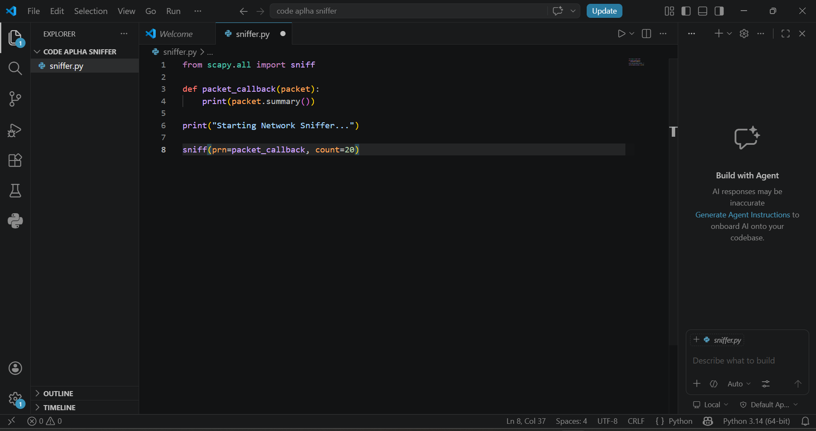
5. CAPTURING OF NETWORKS
When I run the program using the command ‘sniffer.py’, inside the terminal in the VS code, the sniffer captures live network traffic from my computer and displays packet information in the terminal. The output shows different types of packets such as TCP and https traffic, including the source and destination ip addresses. This packets represents live communication happening on the network while browsing websites and using the internet.
